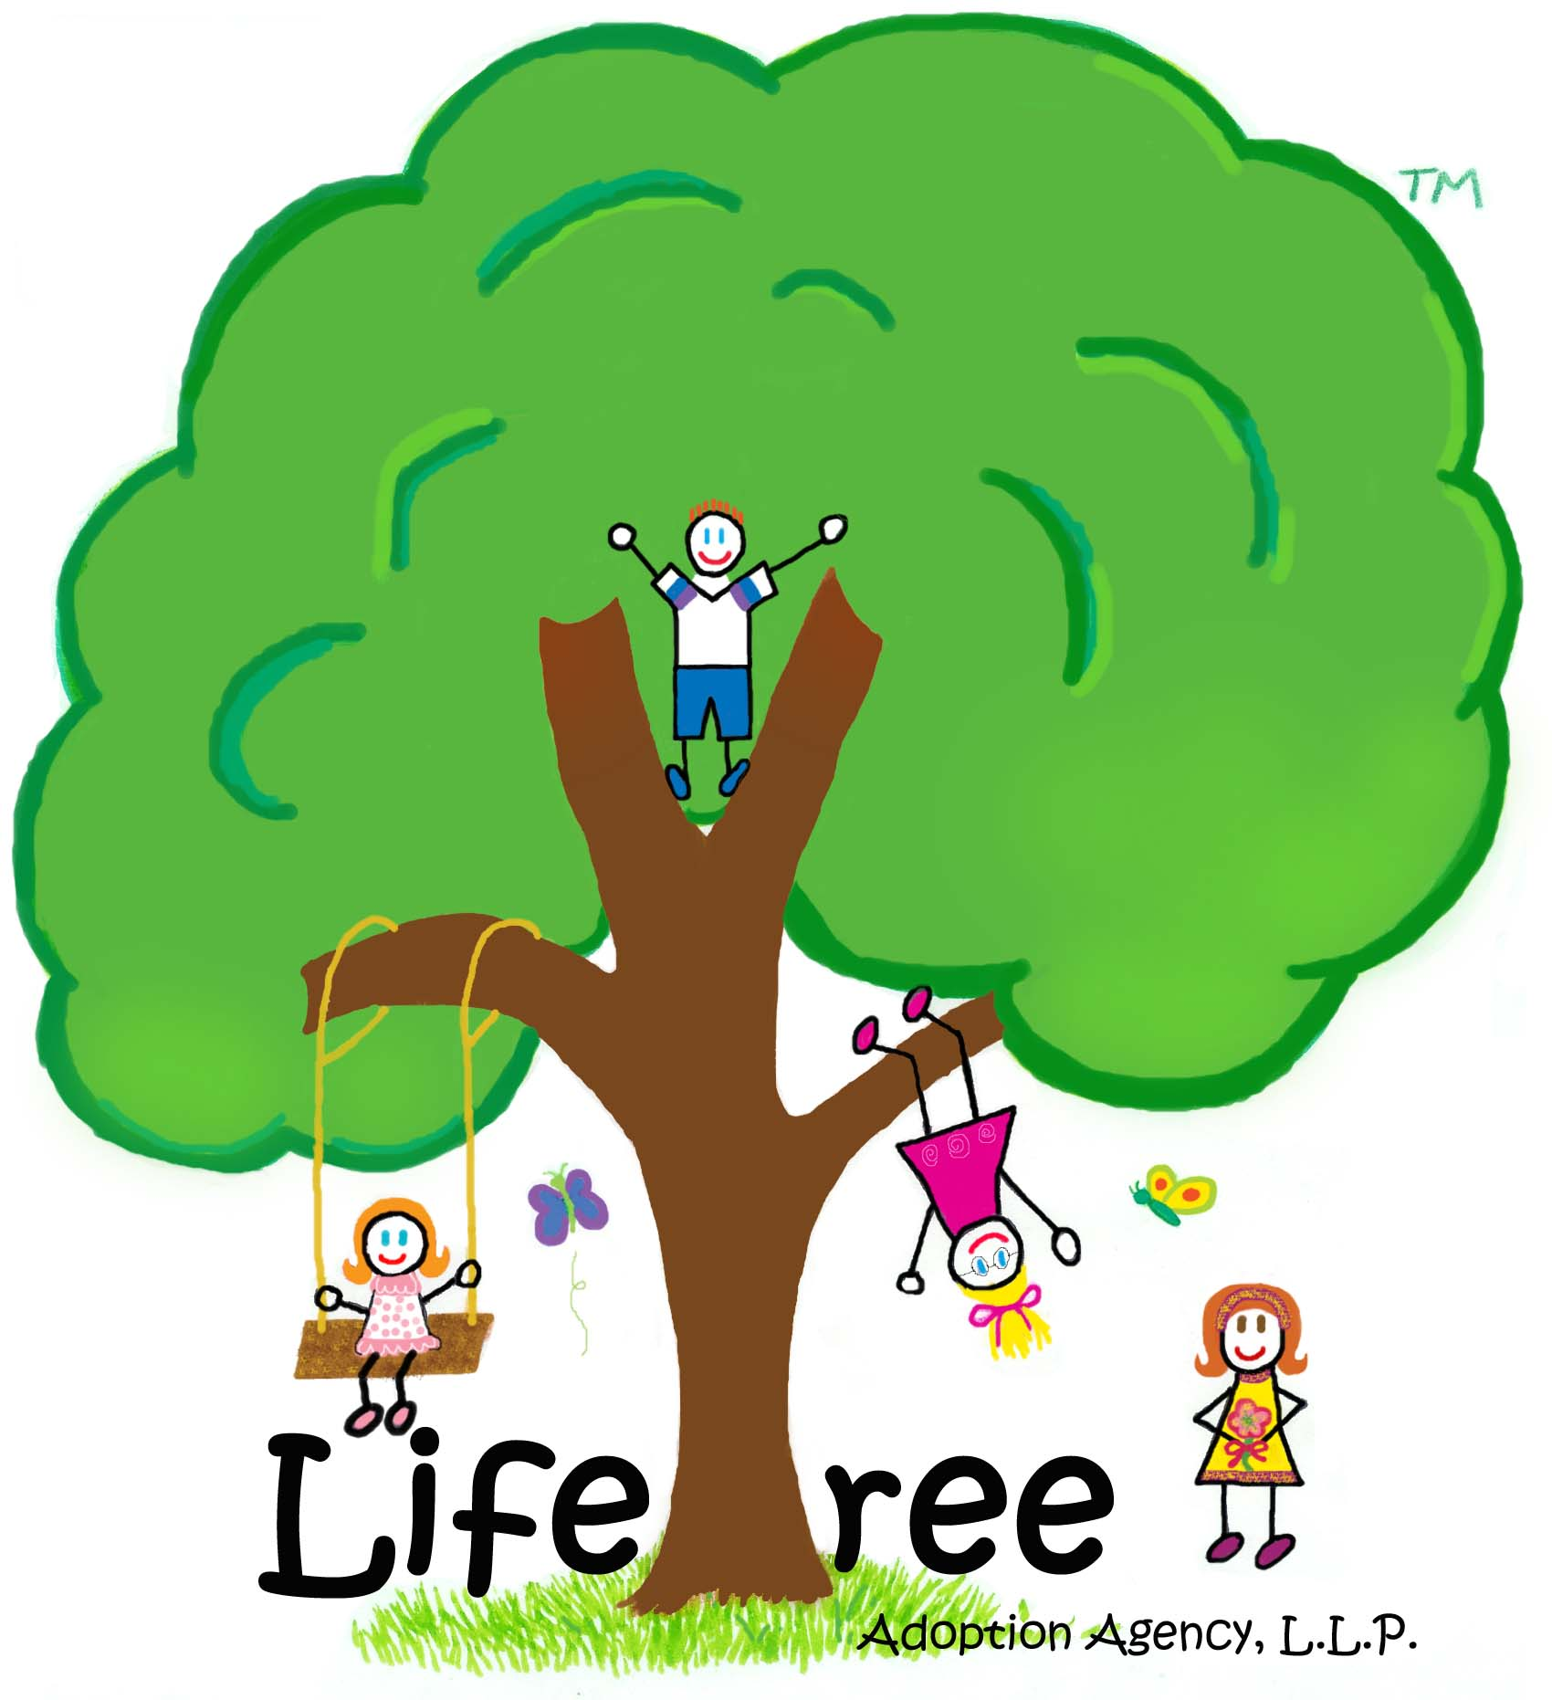
PLEASE DON’T FORGET

TO INCLUDE THE FOLLOWING

WITH YOUR APPLICATION:

CURRENT PHOTOGRAPH
COPY OF DRIVER’S LICENSE OF EACH APPLICANT
COPY OF SOCIAL SECURITY CARD
FLOOR PLAN
(showing dimensions & purposes of each room)
SKETCH/PHOTOGRAPH OF OUTSIDE PLAY AREAS
FIRST PAGE OF MOST RECENT TAX RETURN
COPY OF MOST RECENT PAYCHECK STUB
COPY OF HEALTH INSURANCE CARD
COPY OF LIFE INSURANCE POLICY
(showing coverage amount & beneficiary)
PET VACCINATION RECORDS, if applicable
COPY OF BIRTH CERTIFICATES OF EACH APPLICANT
(including children, if applicable)
COPY OF MARRIAGE LICENSE
DIVORCE DECREE, if applicable
DEATH CERTIFICATE, if applicable
PHOTO ALBUM OR SCRAPBOOK
(including Dear Birthmother Letter, Adoptive Family profile, & current picture)
(972) 491-3333
5220 Spring Valley Road, Suite 550
Dallas, Texas 75254
www.LifetreeAdoption.com

PROSPECTIVE ADOPTIVE FAMILY

APPLICATION
 | Name of Adoptive Family:
Home Address:
(include city, state, zip code)
 | County:
 | Home Telephone Number:
 |  | Husband |  | Wife | Child(ren)
Full Name:
Other Names Used:
(Maiden name/nicknames)
SSN:
DLN and State:
Date of Birth:
Place of Birth:
Telephone Nos.
Mobile: |  |  |  |  | NA
Work: |  |  |  |  | NA
e-mail address: |  |  |  |  | NA
Citizenship:
Language Spoken:
Race:
Religious Preference:
Weight:
Height:
Hair Color:
Eye Color:
Skin Tone:

- List all the cities in Texas each of you have lived?
Husband:
Wife:

- List each of your residence history dating back 10 years.
 | Address, City, State & Zip Code | Length of Time
Husband:
Wife:

- Employment History dating back 10 years.
 | Employer  (Include Address) | Position | Tenure
Husband:
Wife:

- Level of education and present income.
 | Level of Education  (Include Name of School) | Income
Husband:
Wife:

- Financial Status.

INCOME/SAVINGS | COMBINED AMOUNT  ($) | LIABILITIES | MONTHLY COST  ($)
Adjusted Gross Income |  | Mortgage
Personal Savings Accounts |  | Other Mortgage
401K Retirement Accounts |  | Property Taxes
Stocks and Bonds |  | Home Insurance
Other Money Markets |  | Electricity
Inheritance |  | Natural Gas
Child Support or alimony |  | Telephone
Other (specify) |  | Other Utilities
Other (specify) |  | Automobile Loans
TOTAL SAVINGS: |  | Auto Insurance
ASSETS (total value) |  | Health Insurance
 |  | Life Insurance
Residence  (mortgage value) |  | Adoptive Dad
Other Real Estate  (Market Value) |  | Adoptive Mom
Cars (Blue Book Value) |  | Credit Card Debt
Personal Property |  | Other Loans/Debt
Other Assets (specify) |  | Other (specify)
TOTAL ASSETS: |  | TOTAL LIABILITIES:

- Please explain how you will have the funds available for the adoption process.

- Date of Marriage:

- If either of you have had previous marriages, please briefly explain the date of marriage, date of termination, and the reason for termination (i.e., death, divorce, etc.).

- Do either of you have any health or medical problems? If yes, please describe the problem, current medical status, and date of illness or disability.

- Please share both of your positive and negative traits, and describe your personalities.

- Are there any other persons living full time in your home? If yes, please complete the following:
Name | DOB | Sex (M/F) | Relationship

- Give the name, date of birth, and date of death (if applicable) of your children not presently living in your home.
Name | DOB/DOD | Sex (M/F) | Relationship

- Give a brief description of your home (i.e., number of bedrooms, baths, living areas, back yard, etc.).

- Do you have any pets living at your home?

- Please provide the name, address, and telephone number of three references whom we may contact. Be sure to choose friends with whom you are well acquainted.
Reference #1:
Reference #2:
Reference #3:
Reference #4:
Reference #5:

- What do you both do for fun (together and separately)?

- Has there been a worthwhile experience that you shared together as a couple?

- What would you say were some goals you both would like to achieve in your future together?

- Do you mind sharing what your most rewarding experience and your most heartbreaking moment may be?
Rewarding Experience:
Heartbreaking Moment:

- How would you describe a healthy self-esteem and sense-of-worth in your family unit?

- Does God play a large part in each of your lives? What is your religious preference? How often do you both attend church?

- What values and belief systems do you think a family unit should consist of?

- Can you describe the ways you show love and affection towards those you are close to, especially towards a child?

- How would you describe a healthy relationship between parent and child?

- What roles do you think a father plays in the life of a child?

- What roles do you think a mother plays in the life of a child?

- Can you describe the way a child shows affection?

- How would you feel if your child does not react and attach importance to the same matters that are important to you (i.e., affection, education, types of discipline)?

- In what ways do you plan on disciplining your child?

- How do you think you will react and feel towards the way your child displays his/her feelings of anger, fear, and anxiety?

- What sort of goals do you have for your child?

- What educational aspirations do you have for your child?

- If you cannot have children biologically, please explain (i.e., infertility issues).

- Why do you desire to adopt? How did you come to that conclusion?

- Did both of you desire to adopt?

- Can you express your concerns and fears regarding adoption?

- How would you describe your feelings toward adoption?

- How do you feel about Birth Parent(s) who place their child for adoption?

- Do you have any fears about meeting the Birth Parent(s)?

- What type of information are you both willing to share with the Birth Parent(s)? Would both of you be willing to meet the Birth Parent(s) with an agency counselor assisting the meeting? To answer these questions, consider the type of adoption scenario (semi-open, open, closed) that meets your level of comfort.

- What would you say or do if your child someday asks you about his/her Birth Parents?

- What type of child do you both desire to parent? Is there an age range? Is there an ethnic preference? What type of child are you both drawn to?

- Are there any physical, medical, or social issues or any condition you feel uncomfortable accepting in a child?

- Can you explain the type of child you feel most distant towards?

- Would you decline a placement if you felt uncomfortable about the child?

- What are your plans for child care if both of you plan on working full time?

- How would you describe a healthy sibling relationship?

- How would you deal with conflict between your adopted child and other children that may be living in your home?

- Have you worked with another adoption agency? If so, please provide the name and telephone number of the agency.

- How did you learn about Lifetree Adoption Agency?

SIGNED, upon this _________ day of _______________, 20___.

__________________________________ __________________________________
Name of Adoptive Parent Signature of Adoptive Parent

__________________________________ __________________________________
Name of Adoptive Parent Signature of Adoptive Parent

ADOPTIVE FATHER AUTOBIOGRAPHY

Please prepare an autobiography for each of you. The purposes of the autobiography is to help us get to know you better by learning about your background, how you were raised, your family experiences, etc. and to prepare us for the home study. Please write in narrative form rather than short sentences. We realize it is difficult for some people to express themselves in writing; therefore, please do not concern yourselves with correct grammar or spelling, as it is the content that interests us.

The autobiography should include the following information. Once completed, please forward your autobiography to Lifetree Adoption Agency.

Childhood

- Where were you born and what date?

- What is the ethnic origin of your family?

- Describe your parents and your relationship with them. Tell about your parents’ employment and level of education. What was your parents’ occupation during your childhood years? How many brothers/sisters do you have? What position were you in the family (oldest, middle, youngest).

- Who disciplined you the most; what form of discipline was used; and for what misbehavior was it used?

- Describe some unpleasant childhood memories.

- What memories do you have about school?

- Did you have any relatives with whom your family spent a lot of time with (i.e., holidays, vacations, etc.)? Describe your favorite relative.

- What do you wish your parents would have done differently?

- What values did your parents try most to impress upon you?

Teen Years

- Describe your school experiences (i.e., “best friends”, activities, interests, accomplishments, favorite classes, etc.).

- Describe your relationship with your parents during this time. How were you disciplined and for what reason?

- Describe your dating habits. At what age were you allowed to date? What activities did you enjoy?

- What responsibilities did you have at home?

- How important is education to your parents? How important is education to you?

- Did you complete high school? College? Vocational Training?

- Were you ever in the Military?

- What were you likes/dislikes about this period of your life?

- Did you join any clubs, groups, or other organizations?

- What significant experiences did you have during these years which you feel affected you later on? How did it affect you?

- Did you feel the discipline your parents used was appropriate? If no, what would you do differently?

Adulthood

- Describe yourself (i.e., personality, interests, physical description, etc.)

- How do you feel about your vocation (likes/dislikes)?

- What are some of your individual interests?

- If you could change anything about your current situation, what would it be?

- Are you a member of any civic group? If so, what are they, why do you belong, and what is the extent of your involvement?

- What is your current state of health? Have you ever had any serious illnesses or operations? Do you have any disabilities/handicaps?

- Have you ever received any counseling or therapy?
If so, what did you gain from it?

- How do you feel you have changed over the years of marriage? How has your spouse changed?

- If you have any children:
  - When and where were they born?
  - Are they adopted?
  - Are they in school? If so, what grade? How do they do in school?
  - Describe them briefly – their personalities and interests.
  - What form of discipline is used most often, and which parent disciplines?

Previous Marriages

- Were there children by your previous marriage?
If so, where are they now?

- Who has custody?

- Do you visit them or pay child support?

- Why did you and your previous spouse divorce?

ADOPTIVE MOTHER AUTOBIOGRAPHY

Please prepare an autobiography for each of you. The purposes of the autobiography is to help us get to know you better by learning about your background, how you were raised, your family experiences, etc. and to prepare us for the home study. Please write in narrative form rather than short sentences. We realize it is difficult for some people to express themselves in writing; therefore, please do not concern yourselves with correct grammar or spelling, as it is the content that interests us.

The autobiography should include the following information. Once completed, please forward your autobiography to Lifetree Adoption Agency.

Childhood

- Where were you born and what date?

- What is the ethnic origin of your family?

- Describe your parents and your relationship with them. Tell about your parents’ employment and level of education. What was your parents’ occupation during your childhood years? How many brothers/sisters do you have? What position were you in the family (oldest, middle, youngest).

- Who disciplined you the most; what form of discipline was used; and for what misbehavior was it used?

- Describe some unpleasant childhood memories.

- What memories do you have about school?

- Did you have any relatives with whom your family spent a lot of time with (i.e., holidays, vacations, etc.)? Describe your favorite relative.

- What do you wish your parents would have done differently?

- What values did your parents try most to impress upon you?

Teen Years

- Describe your school experiences (i.e., “best friends”, activities, interests, accomplishments, favorite classes, etc.).

- Describe your relationship with your parents during this time. How were you disciplined and for what reason?

- Describe your dating habits. At what age were you allowed to date? What activities did you enjoy?

- What responsibilities did you have at home?

- How important is education to your parents? How important is education to you?

- Did you complete high school? College? Vocational Training?

- Were you ever in the Military?

- What were you likes/dislikes about this period of your life?

- Did you join any clubs, groups, or other organizations?

- What significant experiences did you have during these years which you feel affected you later on? How did it affect you?

- Did you feel the discipline your parents used was appropriate? If no, what would you do differently?

Adulthood

- Describe yourself (i.e., personality, interests, physical description, etc.)

- How do you feel about your vocation (likes/dislikes)?

- What are some of your individual interests?

- If you could change anything about your current situation, what would it be?

- Are you a member of any civic group? If so, what are they, why do you belong, and what is the extent of your involvement?

- What is your current state of health? Have you ever had any serious illnesses or operations? Do you have any disabilities/handicaps?

- Have you ever received any counseling or therapy?
If so, what did you gain from it?

- How do you feel you have changed over the years of marriage? How has your spouse changed?

- If you have any children:
  - When and where were they born?
  - Are they adopted?
  - Are they in school? If so, what grade? How do they do in school?
  - Describe them briefly – their personalities and interests.
  - What form of discipline is used most often, and which parent disciplines?

Previous Marriages

- Were there children by your previous marriage?
If so, where are they now?

- Who has custody?

- Do you visit them or pay child support?

- Why did you and your previous spouse divorce?

PERSONAL REFERENCE OUTLINE

Name of Adoptive Parents:

- How long have you known this couple?

- How would you describe this couples’ personality?

Wife:
Husband:

- What problems, if any, would you say this couple has?

- What does this couple like to do for fun? Do you know of any hobbies?

- Do they have any experience with children?
If so, please explain:

- How would you describe their marriage?

- Are there any habits between the couple that could be considered a negative influence (such as substance abuse, problems with the law, etc.)?

- If you were responsible for a child’s future, would you recommend placing a child into this couple’s home?

- Are there any other issues or concerns that you would like to share?

_______________________________________________

Signature

Please include your address and telephone number above.

Please return this completed form to the address above. You may use the back of this form if more space is needed.

Thank you for your help in this matter.

PERSONAL REFERENCE OUTLINE

Name of Adoptive Parents:

- How long have you known this couple?

- How would you describe this couples’ personality?

Wife:
Husband:

- What problems, if any, would you say this couple has?

- What does this couple like to do for fun? Do you know of any hobbies?

- Do they have any experience with children?
If so, please explain:

- How would you describe their marriage?

- Are there any habits between the couple that could be considered a negative influence (such as substance abuse, problems with the law, etc.)?

- If you were responsible for a child’s future, would you recommend placing a child into this couple’s home?

- Are there any other issues or concerns that you would like to share?

_______________________________________________

Signature

Please include your address and telephone number above.

Please return this completed form to the address above. You may use the back of this form if more space is needed.

Thank you for your help in this matter.

PERSONAL REFERENCE OUTLINE

Name of Adoptive Parents:

- How long have you known this couple?

- How would you describe this couples’ personality?

Wife:
Husband:

- What problems, if any, would you say this couple has?

- What does this couple like to do for fun? Do you know of any hobbies?

- Do they have any experience with children?
If so, please explain:

- How would you describe their marriage?

- Are there any habits between the couple that could be considered a negative influence (such as substance abuse, problems with the law, etc.)?

- If you were responsible for a child’s future, would you recommend placing a child into this couple’s home?

- Are there any other issues or concerns that you would like to share?

_______________________________________________

Signature

Please include your address and telephone number above.

Please return this completed form to the address above. You may use the back of this form if more space is needed.

Thank you for your help in this matter.

PHYSICAL EXAM
Last Name: |  |  |  |  |  |  |  | First Name: |  |  |  |  |  |  | Age:
Name, Address, Phone Number of Physician:
PRESENT CONDITION
Weight: |  |  |  | Height: |  |  |  |  |  |  | Blood Pressure: |  |  | Heart Rate:
Maintenance medication:
General physical condition:
How long has this patient been known to you?
MEDICAL HISTORY
 |  |  |  |  |  |  |  |  |  |  |  |  |  |  |  | Yes |  |  |  | No
* | Is the applicant in good mental and physical health?
* | Does the applicant have a personal or family history of any significant disease(s)  or chronic disabling condition(s)
* | Does the applicant suffer from any communicable disease(s)?
* | Has the applicant ever been hospitalized?
* | Has the applicant ever been treated for emotional problems or mental illness(es)?
* | Has the applicant ever been treated for chemical dependency?
* | Is the applicant expected to have a normal life span?
* | Has the applicant undergone infertility tests and/or treatment?

If the answer to any of the above questions is “yes,” what implications might this have for the applicant’s functioning as an adoptive parent?

Physician’s Signature Date of Exam

AUTHORIZATION FOR RELEASE OF MEDICAL INFORMATION: I hereby authorize my physician or clinic to release any medical information pertinent to the application to LIFETREE ADOPTION AGENCY, L.L.P.

Signature of Prospective Adoptive Parent

PHYSICAL EXAM
Last Name: |  |  |  |  |  |  |  | First Name: |  |  |  |  |  |  | Age:
Name, Address, Phone Number of Physician:
PRESENT CONDITION
Weight: |  |  |  | Height: |  |  |  |  |  |  | Blood Pressure: |  |  | Heart Rate:
Maintenance medication:
General physical condition:
How long has this patient been known to you?
MEDICAL HISTORY
 |  |  |  |  |  |  |  |  |  |  |  |  |  |  |  | Yes |  |  |  | No
* | Is the applicant in good mental and physical health?
* | Does the applicant have a personal or family history of any significant disease(s)  or chronic disabling condition(s)
* | Does the applicant suffer from any communicable disease(s)?
* | Has the applicant ever been hospitalized?
* | Has the applicant ever been treated for emotional problems or mental illness(es)?
* | Has the applicant ever been treated for chemical dependency?
* | Is the applicant expected to have a normal life span?
* | Has the applicant undergone infertility tests and/or treatment?

If the answer to any of the above questions is “yes,” what implications might this have for the applicant’s functioning as an adoptive parent?

Physician’s Signature Date of Exam

AUTHORIZATION FOR RELEASE OF MEDICAL INFORMATION: I hereby authorize my physician or clinic to release any medical information pertinent to the application to LIFETREE ADOPTION AGENCY, L.L.P.

Signature of Prospective Adoptive Parent

INSURANCE INFORMATION

Life Insurance
 | Life Insurance Carrier  (Include Address) | Amount  $ | Beneficiary
Husband:
Wife:

Medical and Health Insurance

 | Health Insurance Provider  (Include Address and Telephone Number) | Amount of Coverage  $ | Amount of Deductible  $ | Who’s Covered
Husband:
Wife:

We authorize Lifetree Adoption Agency, L.L.P. to contact our Insurance Carriers and for our Insurance Carriers to provide Lifetree Adoption Agency, L.L.P the needed information to use the above and foregoing information in making a study of our application. Note: Both parties must sign this form to be valid.

Name of Husband Name of Wife

Signature of Husband Signature of Wife

Date Date

Prospective Adoptive Parents Profile

Include the outline in your photo album/scrapbook. This Profile can be designed in any fashion you desire.

Prospective Father and Mother
- Name
- Age
- Eye color
- Hair color
- Height
- Education
- Employment
- Tell us about your extended family
- What are your hobbies and interest?

How many years have you been married?

Religion Preference?

Is there anyone else living in your home?

What are your child-care plans?

Tell us about your pets.

